PHASE 2 REPORT

Smartphone Sensor Data Analysis and Prediction of Usage Pattern and Overheating using Machine Learning

Problem Id: 24

Section P | G2
Team member 1 (Team Lead)  (Last Name, name, Student ID, University Roll No., email, picture):  Team member 2  (Last Name, name: student ID:, University Roll No email, picture):  Team member 3  (Last Name, name: student ID: , University Roll No email, picture): | Bajaj,Shivansh:2510370470;2028849  2510370470@geu.ac.in    Sharma, Garv : 2510370052,2028716  2510370052@geu.ac.in    Jain,Ketan : 25101281877; 2028743;  25101281877@geu.ac.in  

Problem Description
Smartphones generate a large amount of sensor data such as CPU usage, battery consumption, temperature, memory usage, and other system parameters. Analyzing this data can help understand user behavior and detect potential performance issues such as device overheating.

In this project, machine learning techniques are used to analyze smartphone sensor data and predict device usage patterns as well as overheating conditions. The dataset contains various parameters related to smartphone performance including CPU utilization, battery consumption rate, and other sensor readings. By applying machine learning algorithms such as Logistic Regression and Random Forest, the system learns patterns from historical data to classify the type of usage and detect overheating risks.

This solution can help improve smartphone performance monitoring, prevent hardware damage due to overheating, and optimize battery usage. The project demonstrates how data preprocessing, feature scaling, visualization, and machine learning models can be combined to build a predictive system for real-world applications.
This project extends traditional sensor data analysis by incorporating: - Age Group Prediction (Teenagers, Young Adults, Adults) - Usage Purpose Prediction (Social Media, Gaming, Productivity, Others) - Health Risk Analysis based on excessive usage
Machine learning techniques such as Logistic Regression and Random Forest are used to: - Predict smartphone usage patterns - Detect overheating conditions - Classify users into different age groups - Identify primary usage purpose
Additionally, the system analyzes possible health risks such as: - Eye strain - Sleep disorders - Anxiety and addiction - Reduced physical activity
This solution can help: - Improve smartphone performance monitoring - Provide personalized usage insights - Raise awareness about health risks - Optimize battery and device efficiency

This phase includes data preprocessing and exploratory data analysis (EDA). Missing values were handled, duplicate entries removed, and feature scaling applied. EDA techniques helped identify relationships between smartphone sensor parameters.

- Steps of Implementation:

Data Preprocessing
• Missing value handling using mean and median replacement
• Duplicate removal
• Feature scaling using StandardScaler
• Data normalization

Exploratory Data Analysis
EDA was performed using heatmaps, histograms, and scatter plots to understand data patterns.

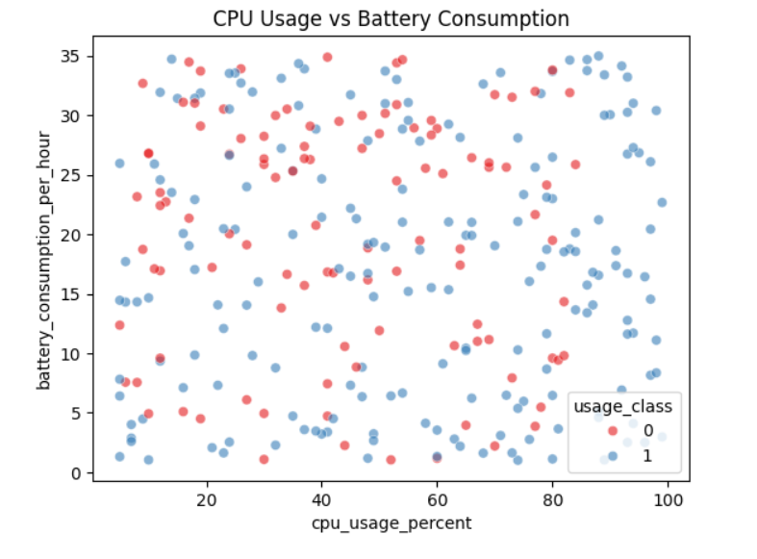
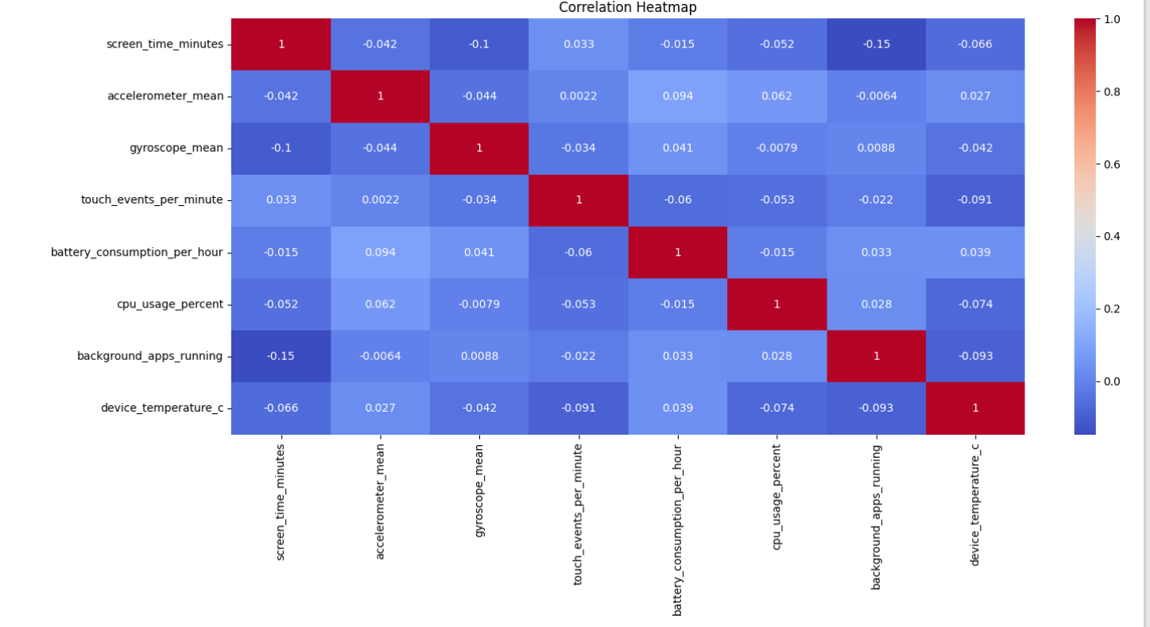
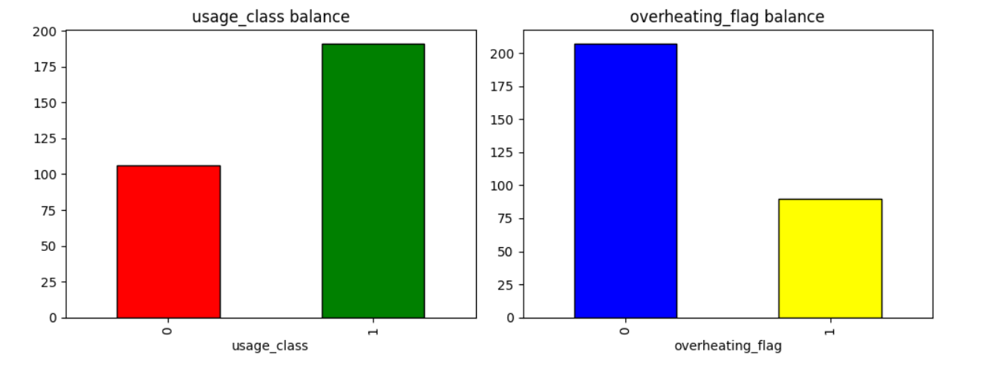

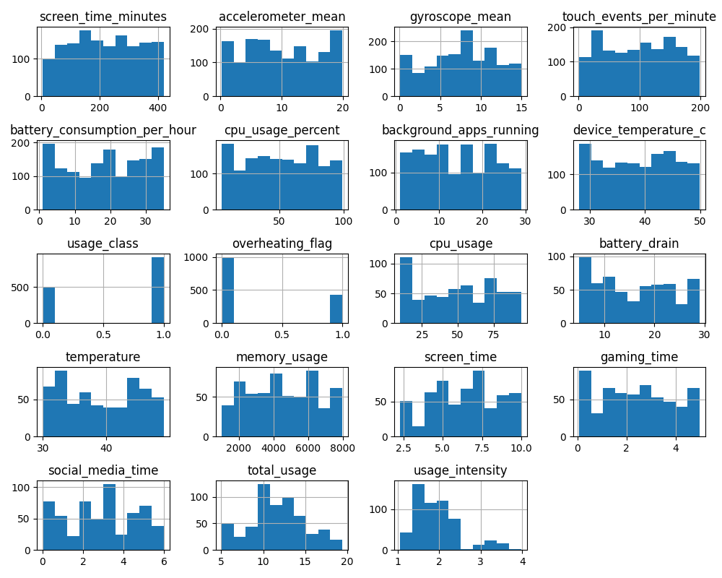
Fig 2: Histogram Visualization
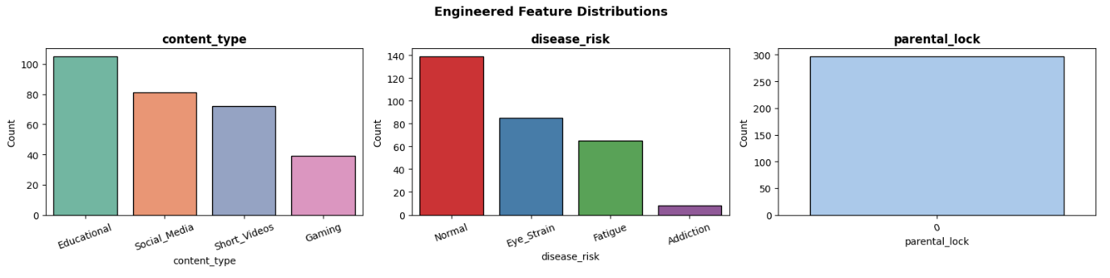

Libraries Used
• Pandas
• NumPy
• Matplotlib
• Seaborn
• Scikit-learn

Architecture
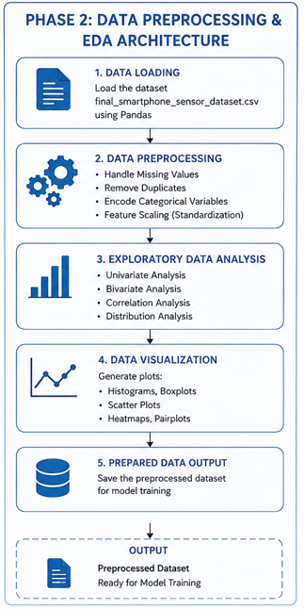

Conclusion
The dataset was successfully preprocessed and analyzed using EDA techniques. The cleaned dataset became ready for machine learning model training.

- Required topics from the subject:
Files – Used to read the dataset stored in CSV format.
Strings – Used for handling column names and categorical labels.
Libraries / Modules – Pandas, NumPy, and Scikit-learn used for ML implementation.

- Platform Required:
• Python
• Jupyter Notebook
• Anaconda / Python IDE
• Libraries: Pandas, NumPy, Matplotlib, Seaborn, Scikit-learn

- Books and Link Sources:
Books:
1. Hands-On Machine Learning with Scikit-Learn, Keras & TensorFlow – Aurélien Géron
2. Python for Data Analysis – Wes McKinney

Online Datasets:
1.Human Activity Recognition Dataset
https://archive.ics.uci.edu/ml/datasets/human+activity+recognition+using+smartphones
Real smartphone accelerometer and gyroscope dataset used for activity classification.

2. MotionSense Dataset
https://github.com/mmalekzadeh/motion-sense
iPhone sensor dataset capturing motion patterns like walking, sitting, and jogging.

3. WISDM Smartphone Dataset
https://www.cis.fordham.edu/wisdm/dataset.php
Dataset containing smartphone sensor data for human activity recognition using accelerometer signals.

4. MobiAct Dataset
https://bmi.hmu.gr/the-mobifall-and-mobiact-datasets-2/
Smartphone-based dataset including normal activities and abnormal movements like falls.

5. ExtraSensory Dataset
http://extrasensory.ucsd.edu/
Multimodal smartphone sensor dataset with detailed context and user activity labels.

6. Kaggle Smartphone Usage Datasets
https://www.kaggle.com/datasets
Collection of datasets containing mobile usage patterns, app activity, and user behavior.
Online Resources:
1. https://scikit-learn.org
2. https://pandas.pydata.org
3. https://www.kaggle.com
4. https://matplotlib.org

